**Snapshots and Process Apps Archiving and Deletion**

**Snapshots record the state of library items within a process application or track at a specific point in time. You can create snapshots in the Process Center console or in IBM® Process Designer. Snapshot management, such as installing, exporting, and archiving, is performed in the Process Center console.**

**Step1: We need to take snapshot of a process.**

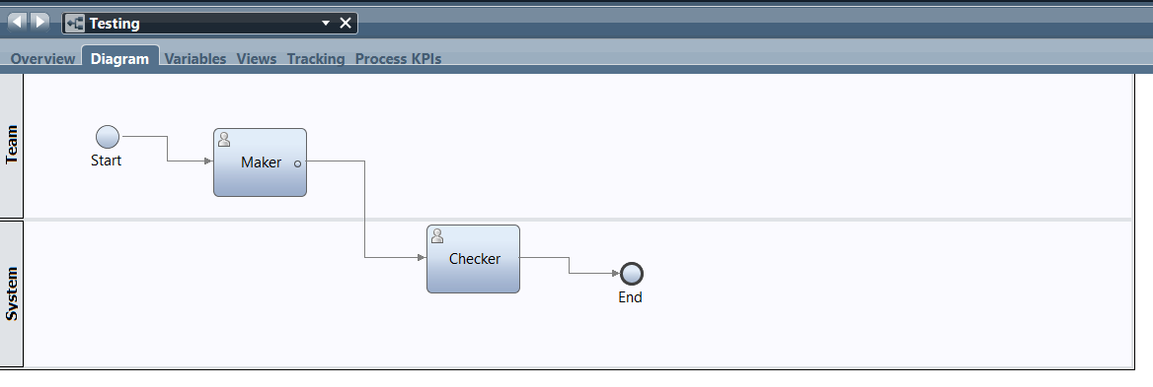

**Step2: After clicking on the snapshot it will display like this, here we need to give snapshot name and click on ok.**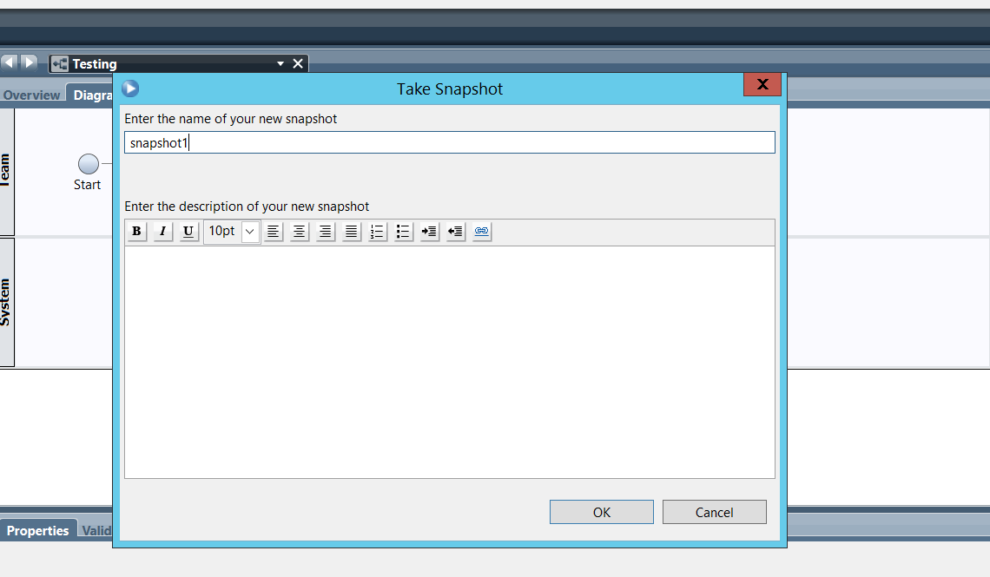

**Step3:After taking snapshot we need to click on manage in that we need to archive the snapshot ,while clicking on archiving it will display a pop up we need to click on archive on that popup message window.**

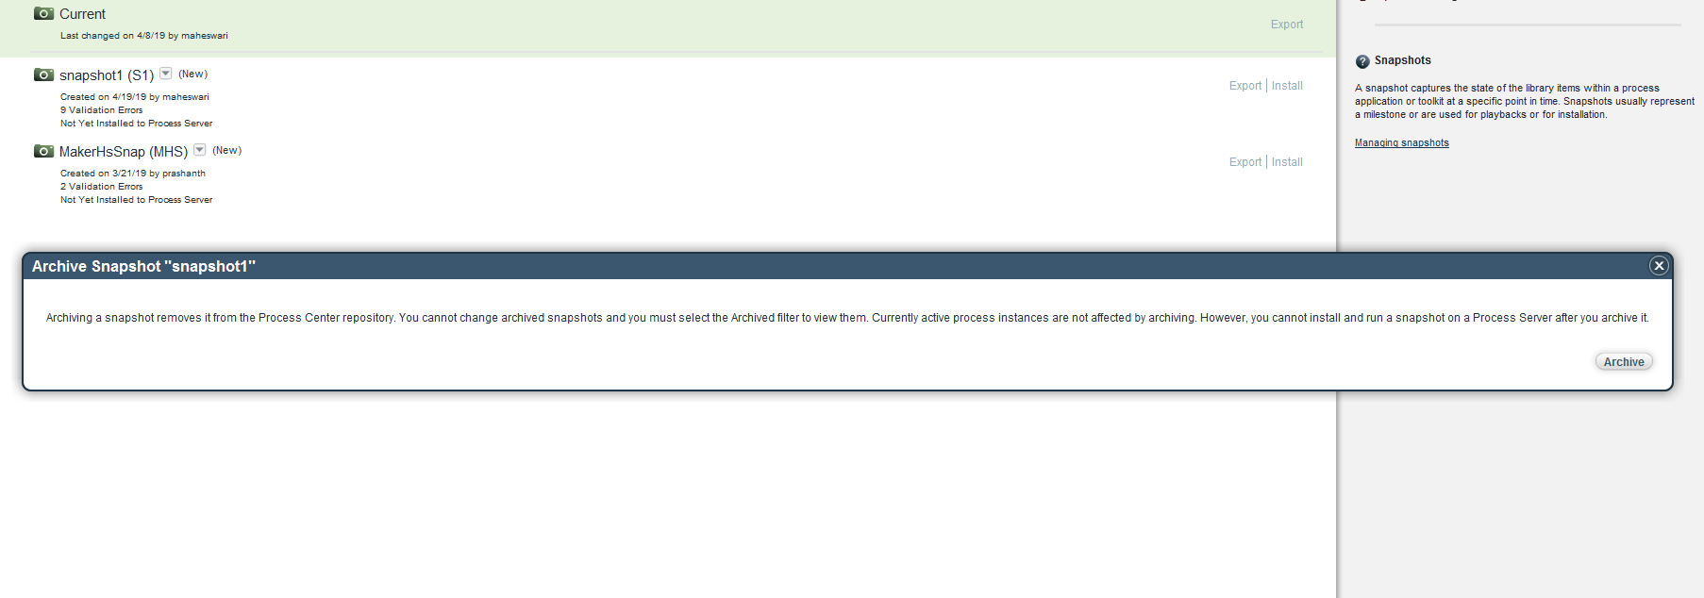**Step4: After it is archived we need to click on archived there that snapshot will be displayed.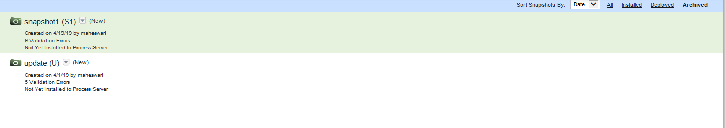Step5: After that we need to delete that through command prompt.**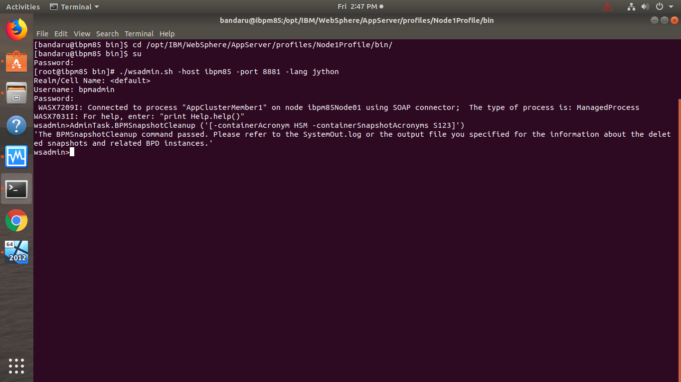

**Step6: After entering the command BPMSnapshotCleanup (‘[-conatinerAcronym (application acronym) –ContainerSnapshotAcronyms (Snapshot name)]’), so that the snapshot will be deleted.**